|  |  |
| --- | --- |
| Air University Home | ***Object Oriented Programming Lab BSSE – II – A***  ***Course Instructor: Abdul Haleem But Lab Instructor: Saima Majeed*** |

**Deadline:** Jun 25, 2021

* *Project description of Cafe Management System*

# *Executive Summary*

***Cafe management system is specially designed for the purpose of elevating the personal***

***experience of ordering online and lessening the daily visit to a nearby cafe. It not only reduces the work load of labor but also has a greater readability. This project automates the process of displaying different items along with their respective prices and also generates a receipt according to the number of items selected by a customer. It has a greater efficiency as each and every detail is aligned. Cafe management system provides a searching facility of a certain item based on its serial number. Each and every item displayed range from 0 to 30. It includes all the necessary validation checks to avoid ambiguities and errors. It has a user friendly interface as it saves time and effort of an end user.***

# *Project Background:*

***No such solution of a Cafe Management exists. If we relate it practically, then cafe or a restaurant would not be needing a manual labor to take their orders by going individually to a customer. A customer is just one tap away from selecting their item. It also allows a customer to select their desired item which in turn reduces human errors in taking different orders manually by going to each customer.***

# *Different than existing solutions:*

# 

# *There’s no existing solution of this system. Each and every proposed functionality is based on some logic and idea*

# *Benefits of Project from end-user point of view:*

***Cafe management system is highly suitable for cafe or a restaurant that intends to lower their manual work load and focus more on reducing human errors while taking different orders. With the help of this designed approach, following are the benefits that a user would have:***

* ***Less chance of misreading the selected item***
* ***Greater readability***
* ***Wide range of items can be selected***
* ***It improves that you are always fully staffed without exceeding the labor budget***
* ***It automates the receipt generation and also calculates the total amount that a user has to pay***
* ***Effective approach of payment has been implemented as the order wouldn’t process until a user would pay the exact amount***
* ***Processes the order in a less amount of time according to a manual labor running at the cafe***
* ***Reliable and safe payment processing***

# *Solution and Approach*

# *Designed interface and the number of available items will be displayed to a user along with the current date and time*

# 

# *User will input the number of items they want*

# *System validates the input and generates a message before any further process*

# *If user enters a valid input, then the system moves ahead*

# 

# *If user enters an invalid input, then the system terminates*

# 

# *User enters the serial number and then further processing takes place*

# *System validates the entered serial numbers and then works according to it*

# 

1. ***If a user enters valid serial numbers, then the selected items are displayed***

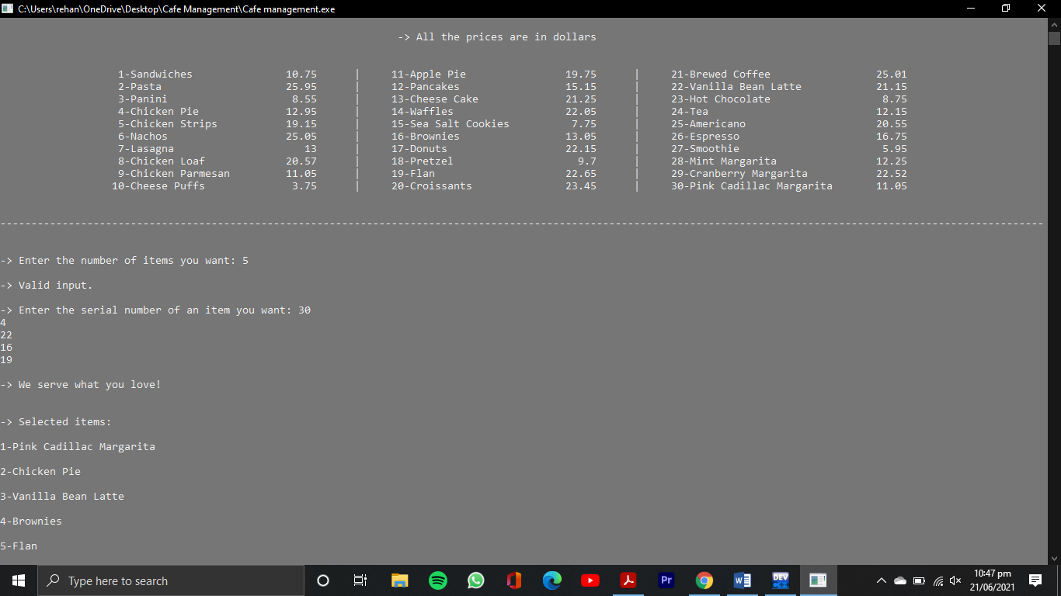

1. ***If a user enters invalid serial numbers, then the system terminates***

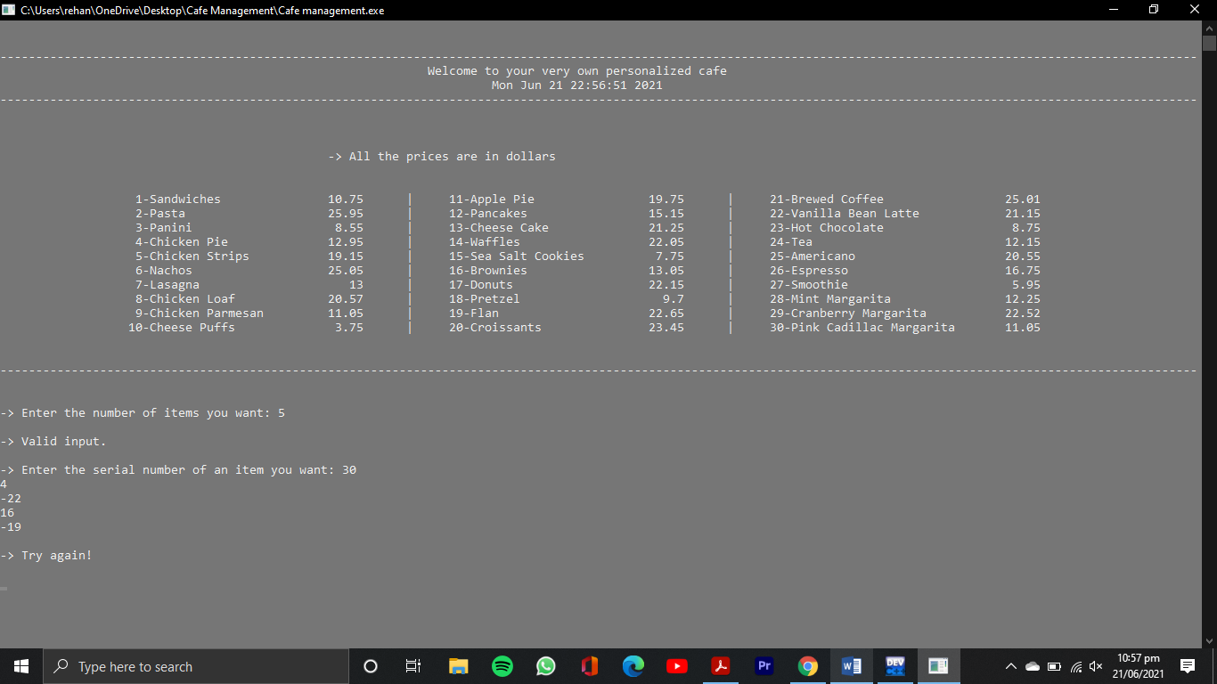

1. ***System generates a bill and the total amount along with the current date and time***

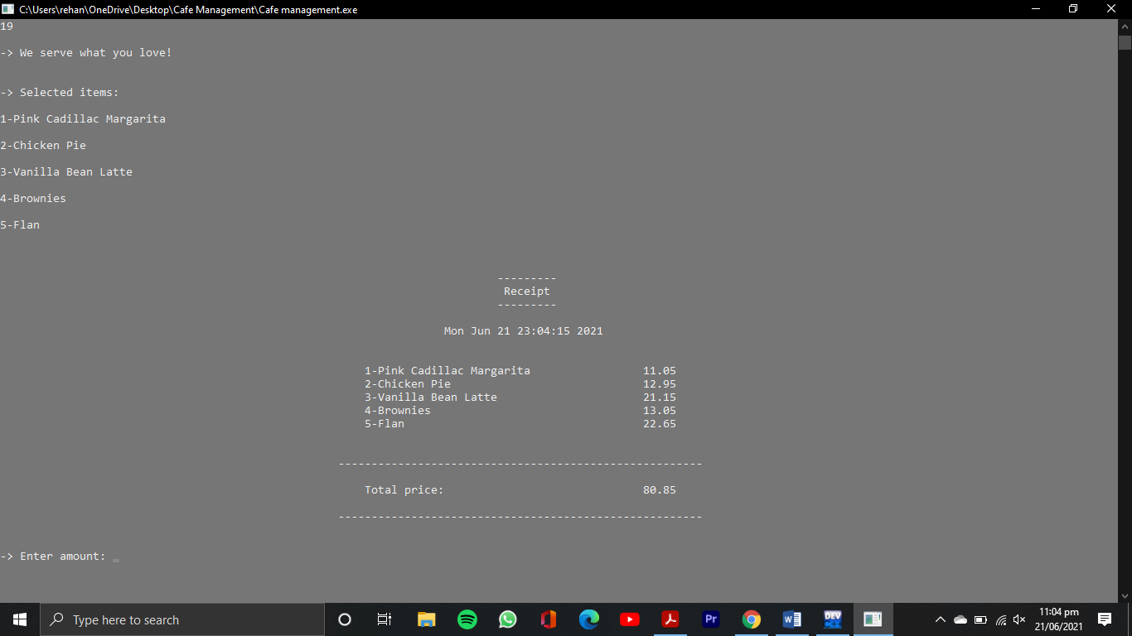

1. ***User enters an amount***
2. ***If user enters a required amount, then the system proceeds forward***

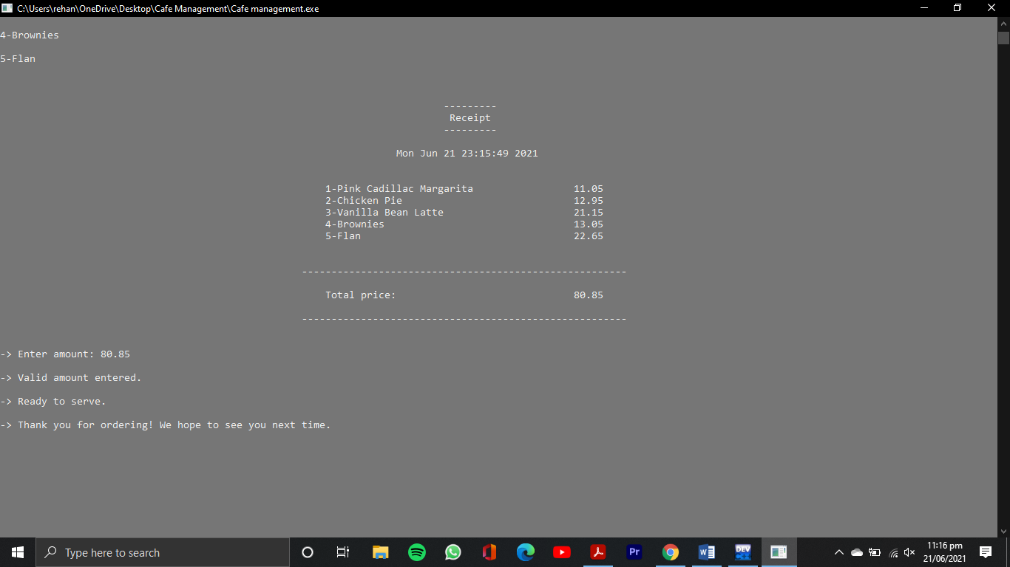

1. ***If user enters an amount greater than a required amount, then a user has to collect the remaining amount from the cash dispenser***

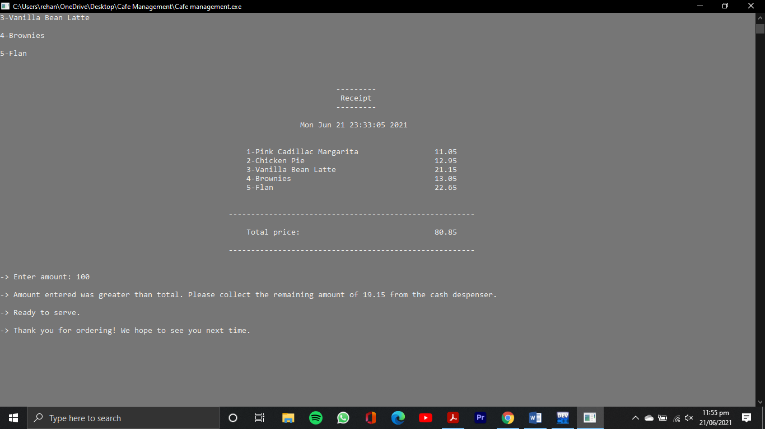

1. ***If a user enters an amount that is not equal to the required amount, then the amount has to be entered again***

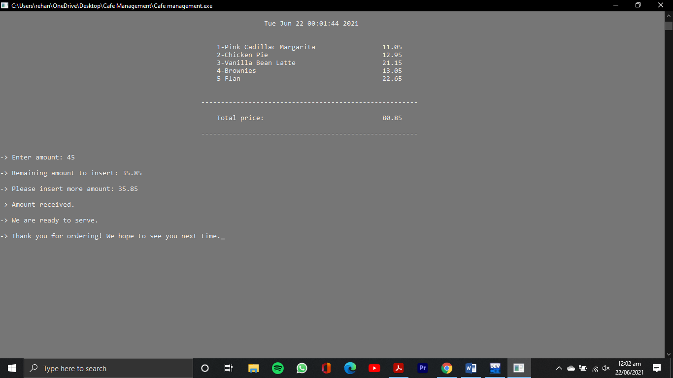

1. ***If user again enters a less amount, then the system is terminated***

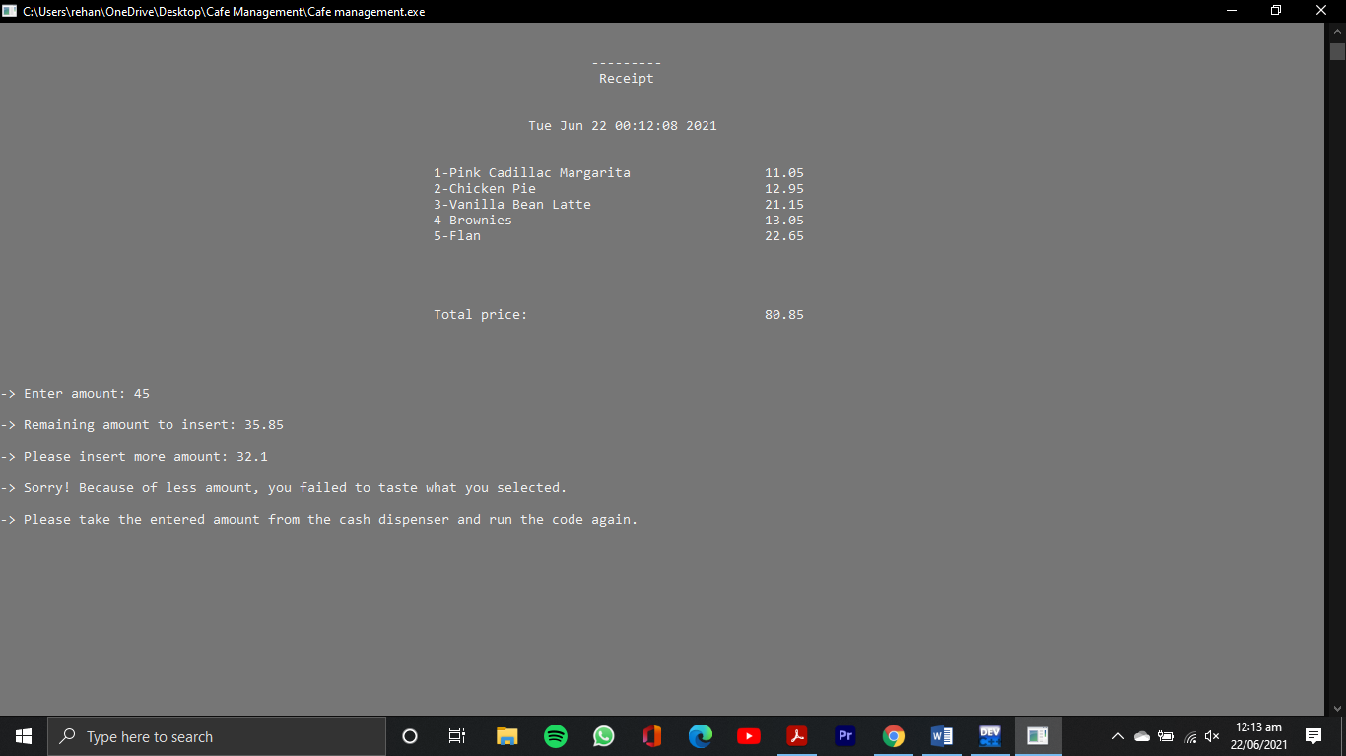

1. ***If a user enters a less amount in the first attempt and then enters a greater amount in the second attempt, then the remaining amount has to be collected from the cash dispenser***

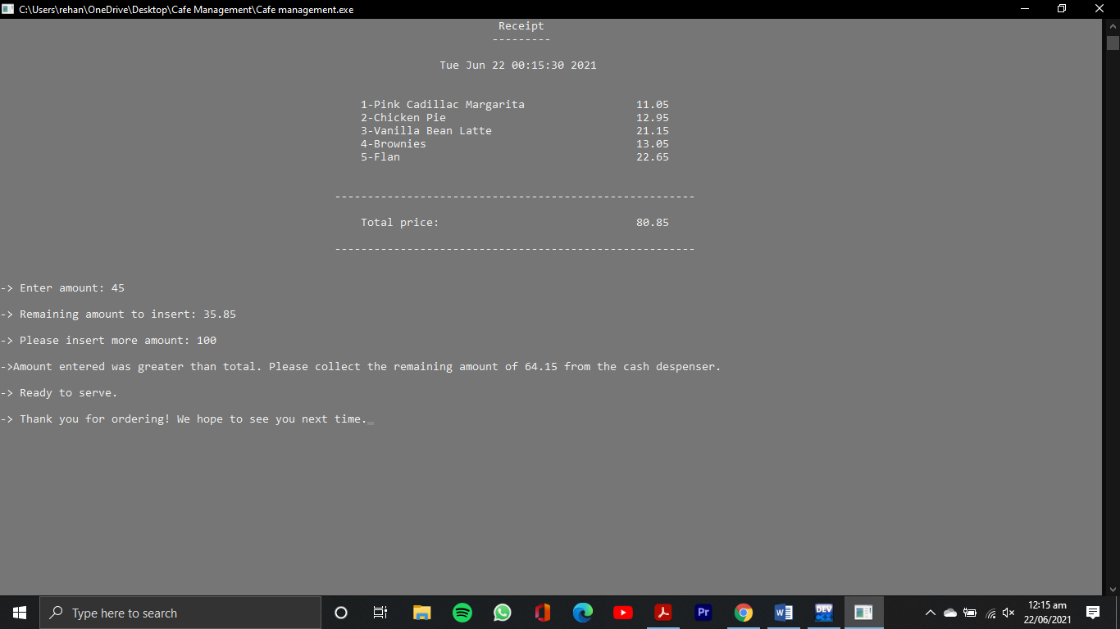

|  |  |  |  |  |  |
| --- | --- | --- | --- | --- | --- |
| ***Class name*** | ***Main Functionality*** | ***Data Members*** | ***Member Functions*** | ***Inherited By*** | ***Applied OOP***  ***Concepts*** |
| ***cafe*** | ***1)Displays the available items***  ***2)Validates all the necessary inputs***  ***3)Generates a receipt***  ***4)Validates the entered amount*** | ***items:string***  ***price:double***  ***num:int*** | ***1)******set_items() : void***  ***2) display_items() : void***  ***3) select() : void***  ***4) input() : void***  ***5) display() : void***  ***6) bill() : void***  ***7) display_message() : void***  ***8) display_error() : void***  ***9) calculate() : void***  ***10) validate_money() : void***  ***11) customer_message() : void***  ***12) display_last() : void*** | ***Nil*** | ***1) Constructor***  ***2) Destructor***  ***3) Friend functions***  ***4) Dynamic memory allocation***  ***5) Header Files*** |

# *Group Members*

***Asmara Irfan-200382***

***Sarah Mujtaba-201299***

***Abdul Rehan-201327***